Environmental Flows in the Context of Wildfires

By: [Raphaela Elise Floreani Buzbee](mailto:refb@berkeley.edu), Caroline Newell,[Leland Scantlebury](mailto:lscantle@ucdavis.edu)

9/12/2023

Word count:*889*  
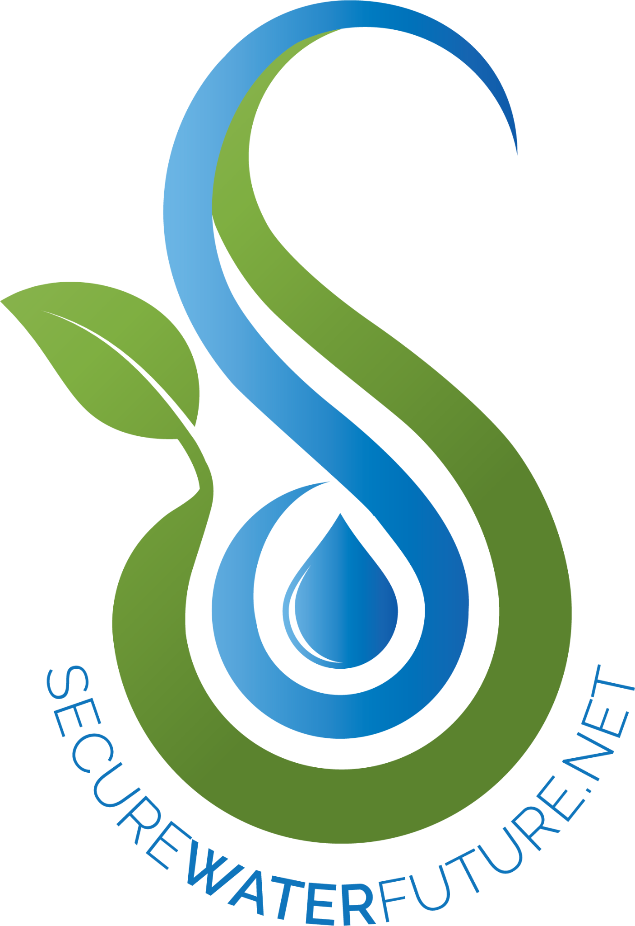

Increased frequency and severity of wildfires across the forests of California and the Western US have sparked concern for watershed health. Changing wildfire patterns impact water resources and hydrological processes which have consequences for fish and wildlife as well as downstream water supply. Modified river systems - rivers where dams regulate the flow of water - have additional controls and limitations when it comes to managing climate change and wildfire effects. Water managers of modified river systems will need to consider wildfire impacts and environmental benefits when planning for future flow regimes that balance competing demands on water resources.

In this brief, we describe methods for managing flows and discuss the impacts of wildfires. This topic applies to many regions around the world, but our area of focus is the Tuolumne River in central California.

**Flow regimes:**

A river’s flow regime is the pattern of flows over time that regulate geomorphic and ecological processes. A flow regime consists of the magnitude, frequency, duration, predictability and rate of change (or flashiness) of flows. For example, rivers draining high mountains tend to have infrequent, high magnitude, long duration flows that have a slow rate of change. These components describe the regime and impact the shapes of river channels and floodplains and determine biodiversity within a river ecosystem (Poff et al., 1997).

Local environmental factors such as soil type and depth, vegetation and watershed size influence natural flow regimes. Given yearly variation in precipitation patterns, many years of flow monitoring data are generally required to fully characterize the flow regime.

**Environmental flows:**

“Environmental flows,” or *e-flows* generally refer to the magnitude, timing, and water quality of stream flows that provide various environmental benefits (Acreman et al., 2014; Yarnell et al., 2015). Initially, e-flows were defined as minimum instream flows necessary to maintain aquatic species but this view has shifted to include different aspects and attributes of the flow regime including different flow magnitudes (Bunn and Arthington, 2002; Acreman and Dunbar, 2004; Acreman et al., 2014). Now, managers focus on using e-flows or functional flows to sustain healthy rivers and maintain ecosystem function while balancing other resource objectives like hydropower (Stein et al. 2021, Willis et al. 2022). It is important to note that e-flows are not regular, repeated flow patterns each year. To mimic natural variation, managers try to allow for variation in timing and magnitude year-to-year.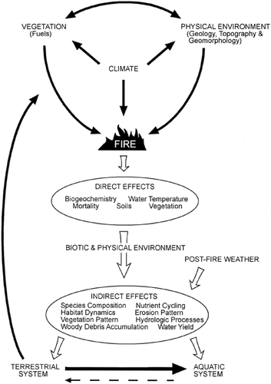

**Wildfire impacts on flows:**

Wildfires are a natural part of the Sierra Nevada ecosystem but wildfires can also have devastating effects on communities and water supplies including water infrastructure and reservoirs, hydropower and fisheries. Globally, regions with Mediterranean climates like California are considered wildfire-watershed risk hotspots. These risks represent a global challenge and require proactive forest management and water governance (Robinne et al., 2021).

Figure 1. Diagram of impacts of fire on aquatic systems from Gresswell 1999.

**Single event wildfire:**

Following a wildfire, like the 2013 Rim Fire in the Tuolumne River watershed, the magnitude of peak flows increased which could lead to more severe flood events. The fire also resulted in increased surface runoff but no noticeable impacts to baseflow. Post-fire evapotranspiration rates were greatly decreased. Discharge was higher in burned areas of the watershed resulting in flashier responses to precipitation and more surface runoff (Blasko, 2020).

**Restored wildfire regimes:**

A nearby watershed with a restored fire regime in the Illilouette Creek Basin had higher annual streamflow, subsurface water storage, and peak snowpack compared to a fire-suppressed watershed. Evapotranspiration and climate water deficit were higher in the fire suppressed watershed (Boisrame et al., 2019). Restoring a natural wildfire regime may increase downstream water availability, shift streamflows slightly earlier, and reduce water stress to forests (Boisrame et al., 2017).

**Wildfire impacts on fish ecology:**

As part of the California landscape, wildfires play an important role in shaping aquatic ecological systems (Gresswell, 1999; Van de Water and Safford, 2011). Many native species have adapted to periodic disturbances from fires, but fire impacts have changed as human influence has modified fire regimes and behavior (Van de Water and Safford, 2011; Bixby et al., 2015). The impacts of fire are compounded in systems that are already facing other stressors like drought, invasive species, and infrastructure (dams) (Moyle, 2002).

Impacts vary by fire characteristics - area burned, timing in relation to fish migrations and rearing, fire severity, and how much of the landscape burned. Impacts may be immediate and long-term, with fish kills being documented up to two years post-fire (Bozek and Young, 1994). Fires can induce poor water quality through pollution from sediment, heat, toxins, and nutrients. These changes in water quality lead to burial of organisms, gill damage, toxicity, hypoxia, alkalinity, and thermal stress (Figure 1, Gresswell, 1999).

**E-flows in the context of fire:**

Managers who wish to implement flows that are best suited to the needs of their ecological systems are advised to gather monitoring data for their system to determine baseline species assemblages to inform best practices. During a fire, allowing more water to flow may buffer against high temperatures. Post fire, large storms that wash silt and debris should raise concerns for water quality and prompt releases sufficient for flushing out pollutants. In the long term, environmental flows with functional elements will buffer populations against wildfire disturbances and promote vegetation recruitment along banks to supply critical shading structures along the riparian zone (Grantham et al., 2020).

# **Acknowledgements:**

This brief was written by graduate student participants of the UC Water Academy Wildfire and Water workshop August - September 2023. Special thanks to UCWA funders, organizers, mentors and participants.

This work is supported by Agriculture and Food Research Initiative Competitive Grant no.

2021-69012-35916 from the USDA National Institute of Food and Agriculture.

# **References:**

Acreman, M., Arthington, A.H., Colloff, M.J., Couch, C., Crossman, N.D., Dyer, F., Overton, I., Pollino, C.A., Stewardson, M.J., Young, W., 2014. Environmental flows for natural, hybrid, and novel riverine ecosystems in a changing world. Frontiers in Ecology and the Environment 12, 466–473.<https://doi.org/10.1890/130134>

Acreman MC and Dunbar MJ. 2004. Defining environmental river flow requirements – a review. Hydrol Earth Syst Sc 8: 861–76.

Blasko, C., 2020. Assessing hydrologic impacts of the 2013 Rim Fire on the Tuolumne River Watershed in Central Valley, California (Doctoral dissertation, Bowling Green State University).

Bixby, R.J., Cooper, S.D., Gresswell, R.E., Brown, L.E., Dahm, C.N., Dwire, K.A., 2015. Fire effects on aquatic ecosystems: an assessment of the current state of the science. Freshwater Science 34, 1340–1350.<https://doi.org/10.1086/684073>

Boisramé, G., Thompson, S., Collins, B. and Stephens, S., 2017. Managed wildfire effects on forest resilience and water in the Sierra Nevada. *Ecosystems*, *20*, pp.717-732.

Boisramé, G.F., Thompson, S.E., Tague, C. and Stephens, S.L., 2019. Restoring a natural fire regime alters the water balance of a Sierra Nevada catchment. *Water Resources Research*, *55*(7), pp.5751-5769.

Bozek, M.A., Young, M.K., 1994. Fish mortality resulting from delayed effects of fire in the Greater Yellowstone Ecosystem. GREAT BASIN NATURALIST 54, 6.

Bunn SE and Arthington AH. 2002. Basic principles and ecological consequences of altered flow regimes for aquatic biodiversity. Environ Manage 30: 492–507.

Grantham, T. and Mount, J.F., 2020. *Making the Most of Water for the Environment: A Functional Flows Approach for California's Rivers*. Public Policy Institute of California.

Gresswell, R.E., 1999. Fire and Aquatic Ecosystems in Forested Biomes of North America. Transactions of the American Fisheries Society 128, 193–221. [https://doi.org/10.1577/1548-8659(1999)128<0193:FAAEIF>2.0.CO;2](https://doi.org/10.1577/1548-8659(1999)128%3C0193:FAAEIF%3E2.0.CO;2)

Moyle, P.B., 2002. *Inland fishes of California: revised and expanded*. Univ of California Press.

Poff, N. L., Allan, J. D., Bain, M. B., Karr, J. R., Prestegaard, K. L., Richter, B. D., Sparks, R. E., & Stromberg, J. C. 1997. The Natural Flow Regime. *BioScience*, *47*(11), 769–784. https://doi.org/10.2307/1313099

Robinne, F.N., Hallema, D.W., Bladon, K.D., Flannigan, M.D., Boisramé, G., Bréthaut, C.M., Doerr, S.H., Di Baldassarre, G., Gallagher, L.A., Hohner, A.K. and Khan, S.J., 2021. Scientists' warning on extreme wildfire risks to water supply. *Hydrological Processes*, *35*(5), p.e14086.[.](https://onlinelibrary.wiley.com/doi/full/10.1002/hyp.14086)

Stein, E.D., Zimmerman, J., Yarnell, S.M., Stanford, B., Lane, B., Taniguchi-Quan, K.T., Obester, A., Grantham, T.E., Lusardi, R.A. and Sandoval-Solis, S., 2021. The California environmental flows framework: meeting the challenges of developing a large-scale environmental flows program. *Frontiers in Environmental Science*, *9*, p.769943.

Van De Water, K.M., Safford, H.D., 2011. A Summary of Fire Frequency Estimates for California Vegetation before Euro-American Settlement. fire ecol 7, 26–58.<https://doi.org/10.4996/fireecology.0703026>

Willis, A.D., Rheinheimer, D.E., Yarnell, S.M., Facincani Dourado, G., Rallings, A.M. and Viers, J.H., 2022. Shifting trade-offs: Finding the sustainable nexus of hydropower and environmental flows in the San Joaquin River watershed, California. *Frontiers in Environmental Science*, *10*, p.787711.

Yarnell, S.M., Petts, G.E., Schmidt, J.C., Whipple, A.A., Beller, E.E., Dahm, C.N., Goodwin, P. and Viers, J.H., 2015. Functional flows in modified riverscapes: hydrographs, habitats and opportunities. *BioScience*, *65*(10), pp.963-972.